THALES AVIONICS SAS
3 Rue Toussaint Catros
33187, Le Haillan Cedex
France
Tel. : +33 (0)5 56 13 50 00
Fax : +33 (0)5 56 13 50 50
www.thalesgroup.com

Procedure for installation of A661p2 simulator

Follow-up of the evolutions

LOG OF CHANGES
Revision | Date | Author | Modification
001 | 16/03/2016 | M. DECHATRE  (THALES) | Initialization of the document
002
003

APPROVAL
 | Name | Entity | Date | Signature
Written by | M. DECHATRE | THALES | 16/03/2016
Approved by | N. LEPRON | THALES | 16/03/2016

CONTENT
CONTENT 3
1 INSTALLATION PROCEDURE 5
1.1 Step 1: Unzip the binaries folder 5
1.2 Step 2: Install Qt 6
1.3 Step 3: Configure A661p2 Launcher 10
2 DEPLOYMENT PROCEDURE 12
2.1 Installation of Qt environment 12
2.2 Gathering of required libraries 12
2.2.1 MinGW 12
2.2.2 JOGL 12
2.2.3 ShivaVG 13
2.2.4 Glut 13
2.2.5 Jpeg 13
2.3 Modification of Shiva VG library 13
2.4 Compilation of required libraries 13
2.4.1 MinGW 13
2.4.2 JOGL 13
2.4.3 ShivaVG 13
2.4.4 Glut 14
2.4.5 Jpeg 14
2.5 Compilation of the A661p2 simulator 14
2.6 Running the simulator 14
3 SPECIFICATION COMPLIANCE 15
4 KNOWN LIMITATIONS 16
4.1 Standard types support 16
4.2 Graphic primitives 16
4.2.1 Capacities: 16
4.2.2 Primitives 16
4.3 Behavior 16

INSTALLATION PROCEDURE

Step 1: Unzip the binaries folder
Alongside this document is provided an archive containing the required files for the installation of this A661p2 Simulator.

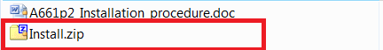

This archive shall be unzipped in a directory where executions rights are granted for the current user.
It contains the following data:

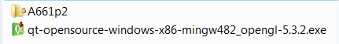

The A661p2 folder contains the binaries allowing running the simulator.
The qt-opensource-windows-x86-mingw482_opengl-5.3.2.exe is the Qt installer setting the utilities required by the simulator.

Step 2: Install Qt
First of all, user shall install the Qt environment using the provided installation file according to the following steps:
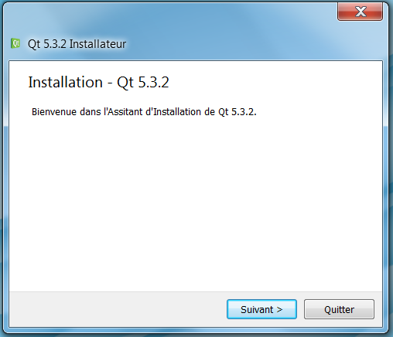
The location of the installation is important for following steps of deployment:
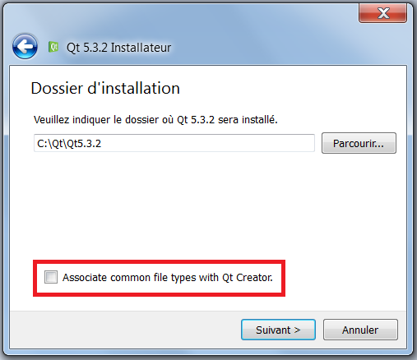

Feel free to unselect the checkbox to avoid having all C related files to be opened with QtCreator IDE.
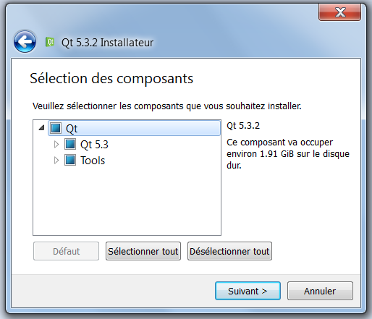
Make sure to agree the terms of the license agreement:
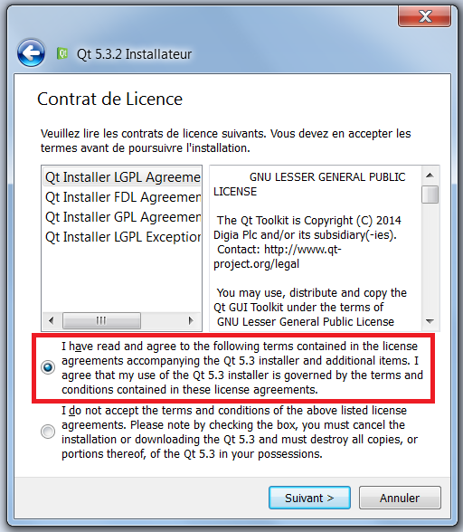
Select the name of the Start Menu shortcut you wish to see:
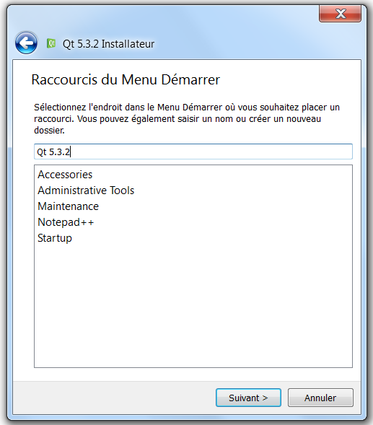

Start the installation:
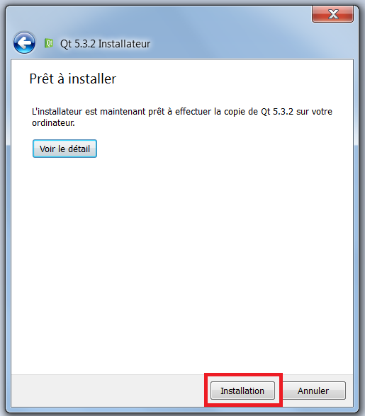

Once it is over, perform Step 3.

Step 3: Configure A661p2 Launcher
Two subfolders are located under A661p2 element:
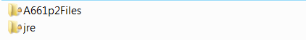
The jre folder contains the Java Runtime Environment required by the A661 simulator to be executed.
The actual simulator binaries are located under A661p2Files directory:
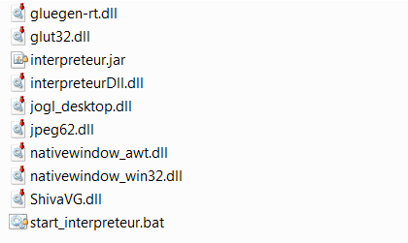
User shall modify the start_interpreteur.bat file to specify the path of the Qt installation:
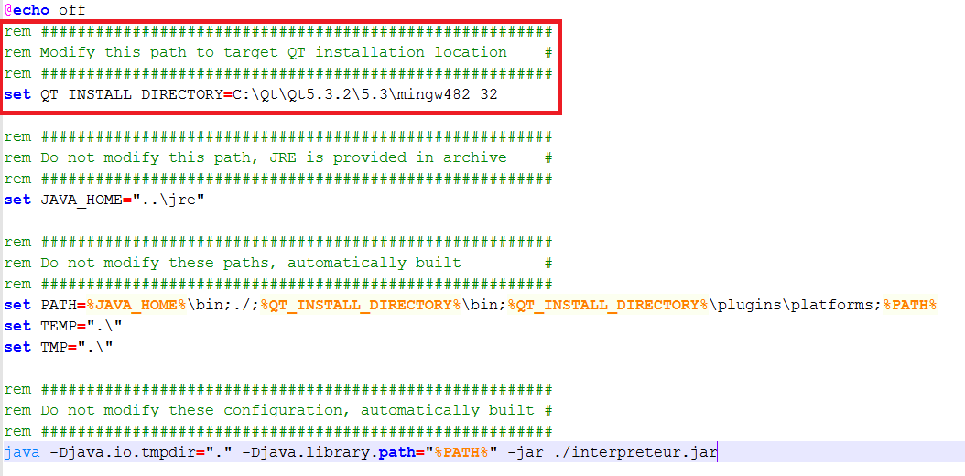
The QT_INSTALL_DIRECTORY value shall be modified according to the directory which has been selected during Qt installation.

Make sure that there is no network location in your %PATH% environment variable (for instance \\OTHER_COMPUTER).
Launching start_interpreteur.bat now starts the simulator; an A661p2 specification file may now be selected:
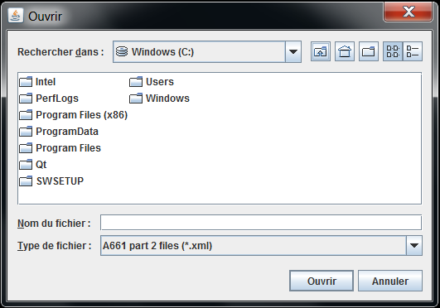

DEPLOYMENT PROCEDURE

Installation of Qt environment
Qt environment can be retrieved from the following location:
http://download.qt.io/archive/qt/5.3/5.3.2/qt-opensource-windows-x86-mingw482_opengl-5.3.2.exe
This version of Qt Creator is not the last and up-to-date one, but the simulator building and running have been tested using this environment.
Ascending compatibility may be possible, but is not guaranteed.
To install the IDE, please follow instructions as explained under Chapter 1.2: “Step 2: Install Qt”

Gathering of required libraries
The following libraries that shall be retrieved and deployed before use of the A661p2 Simulator are described below.
Please take into account all the license agreements as described under this file: 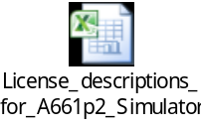

MinGW
The required libraries accessible from MinGw installation are:
- icudt52.dll
- icuin52.dll
- icuuc52.dll
- libgcc_s_dw2-1.dll
- libstdc++-6.dll
- libwinpthread-1.dll
These libraries are accessible under the Qt installation (which deploys MinGw 4.8.2), under the folder: \Qt5.3.2\5.3\mingw482_32\bin

JOGL
JOGL Library can be retrieved from the following location:
http://jogamp.org/deployment/archive/master/gluegen_646-joal_408-jogl_930-jocl_756/archive/jogamp-all-platforms.7z

Feel free to install the 32 or 64 bits Windows version according to the computer you are working on.
The libraries which are required by the A661p2 Simulator are:
- gluegen-rt.dll
- jogl_desktop.dll
- nativewindow_awt.dll
- nativewindow_win32.dll

ShivaVG
ShivaVG library source files can be retrieved from the following location:
https://github.com/ileben/ShivaVG

Glut
Glut library source files and binaries can be retrieved from the following location:
https://www.opengl.org/resources/libraries/glut/glut37.zip

Modification of Shiva VG library
ShivaVG source files shall be modified to correct a bug existing in the current distribution.
Please replace the shImage.c file using this one:
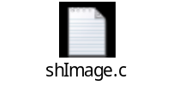

Compilation of required libraries

MinGW
As MinGw is provided with Qt installation, there is no need to build those libraries.

JOGL
The JOGL libraries are already built inside the downloadable archive.
However, you can be the libraries using their provided makefile.

ShivaVG
After replacement of the shImage.c file inside ShivaVG source folder, the ShivaVG binary files can be built using the provided makefile.

Glut
The GLUT libraries are already built inside the downloadable archive.
However, you can be the libraries using the glutmake.bat script.

Running the simulator
To run the simulator, please organize your artifacts as given under zip file, and follow instructions as explained under Chapter 1.3: “Step 3: Configure A661p2 Launcher”

SPECIFICATION COMPLIANCE
The A661p2 simulator digests XML files describing scenes through objects definitions.
These XML files shall be compliant with the following XSD files:

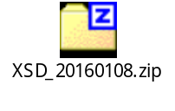

KNOWN LIMITATIONS

Standard types support
All standard types are supported, except
- FormatStringType
- CustomXXXType

Graphic primitives

Capacities:
- Core capacities are fully supported
- Paint capacities are fully supported
- Graphics are supported with the following limitations:
    - Visibility : TBD
    - DrawingPriority is correctly read but have no impact
- ClipCapacities attributes are correctly read but have no impact
- ClipPath is not supported
- FilterCapacities are not applicable, and no attribute is defined yet
- TransformCapacities are applicable with the following limitation:
Only one transformation can be applied with static parameters (bindings are not supported yet).
A way to bypass this limitation is to use TransformItem with x and y attributes
A good example of the use of this item can be found inside the Rectanlge.part2 sample file.

Primitives
- Children hierarchy is fully supported
- Images primitive supports JPEG source files only

Behavior
POINTER.x and POINTER.y events can be used to retrieve x and y values of the pointer, in addition to event.x/event.y.

General usage
There may be a gap between the windows pointer position and the x/y coordinates of the pointer taken into account by the simulator.
To correct this gap, you can modify the zoom level using the “*” key which allows you to swap windowing modes between “scale” and “crop”, and the “+” and “-” which will let you zoom and un-zoom the viewpoint in the simulator.

